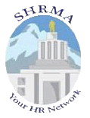 | SHRMA  Salem Human Resources  Management Association  shrmsalem.org

Chapter Newsletter

July 2012 Edition

Message from Chapter President, Barbara Cecil
What is a Volunteer?
Out of sheer curiosity, I recently Googled the word VOLUNTEER and was surprised to see the following definition . . .
vol·un·teer 1) somebody who works for nothing: somebody who works without being paid; and 2) somebody acting voluntarily: somebody who does something voluntarily, especially something undesirable.
I had to ask myself, is that what people think when they’re asked to volunteer their time? Reflecting on my past three and a half years as a volunteer board member for SHRMA, I refused to accept this definition, let alone apply it to my experience with this organization and the wonderful people I’ve had the opportunity to meet through my involvement.
So, I consulted Wikipedia, where I received the following response . . .
Volunteering is generally considered an altruistic activity, intended to promote good or improve human quality of life. It is considered as serving the society through one’s own interest, personal skills or learning, which in return produces a feeling of self-worth and respect, instead of money. Volunteering is also famous for skill development, to socialize and to have fun. It is also intended to make contacts for possible employment or for a variety of other reasons”.
Thank you, Wikipedia, for more accurately reflecting the spirit of volunteerism!!

Volunteerism and SHRM
In 1948, a group of 28 professionals dedicated to the advancement of the personnel profession formed the American Society for Personnel Administration (ASPA), now known as the Society for Human Resource Management (SHRM). Those 28 professionals were SHRM's first volunteers
How Volunteerism Works for our Chapter
Volunteers at the local Chapter level are critical to the success of the HR profession in our community, much like SHRM's volunteer leaders have been critical to the organization's success and to the overall advancement of the human resource profession.
Our Salem SHRMA Chapter board is comprised of HR professionals from a diverse group of employers. The board meets monthly to carry out the responsibly of ensuring our Chapter remains a valuable educational and networking resource to HR professionals in our community. We have a history of providing developmental/networking opportunities for HR professionals, as well as providing support to local charity organizations, such as Easter Seals of Oregon.

Last year our Chapter was awarded the SHRM Platinum Excel Award for outstanding achievements, and we hope to be equally successful in the coming years. But we need your help! We are gearing up for our 2013 board elections process and are seeking individuals interested in giving back to the HR profession, as well as helping our Chapter achieve continued success.

You Can Help!

Do you have a passion for HR and for helping others in our field? If so, President-Elect Scott Cantu and I would like to hear from you, so we can discuss how your talents can serve the Chapter.

Please email me at: bcecil@mapscu.com or Scott at Scott.L.Cantu@doc.state.or.us so we can set up a time to visit with you about this rewarding opportunity.

Take Advantage of a Great Networking Opportunity
Katie Clapper, Ambassador

SHRMA Chapter involvement is an excellent opportunity to meet other HR professionals, hear more about what they are doing in their organizations, and learn from each other. Here are just a handful of helpful hints for networking:
- Bring business cards to hand out to people you meet at our monthly meetings, and ask for them in return.
- Be bold—introduce yourself; don’t wait for someone else to make the first move.
- Ask questions about the other person and their organization.
- Follow up with an email or phone call to those that you have made a connection with. You never know when that connection might provide valuable insight or an answer to a particularly challenging HR question.
Happy networking everyone!
2012 PHR/SPHR Study Group  Laurie South, Professional Development Director  We’re pleased to announce that our partnership with Oregon State Personnel Management Association (OSPMA) has enabled us to offer a Fall study group for SHRMA members seeking to earn their PHR/SPHR Certification. Several Chapter members have taken advantage of the opportunity to join the | 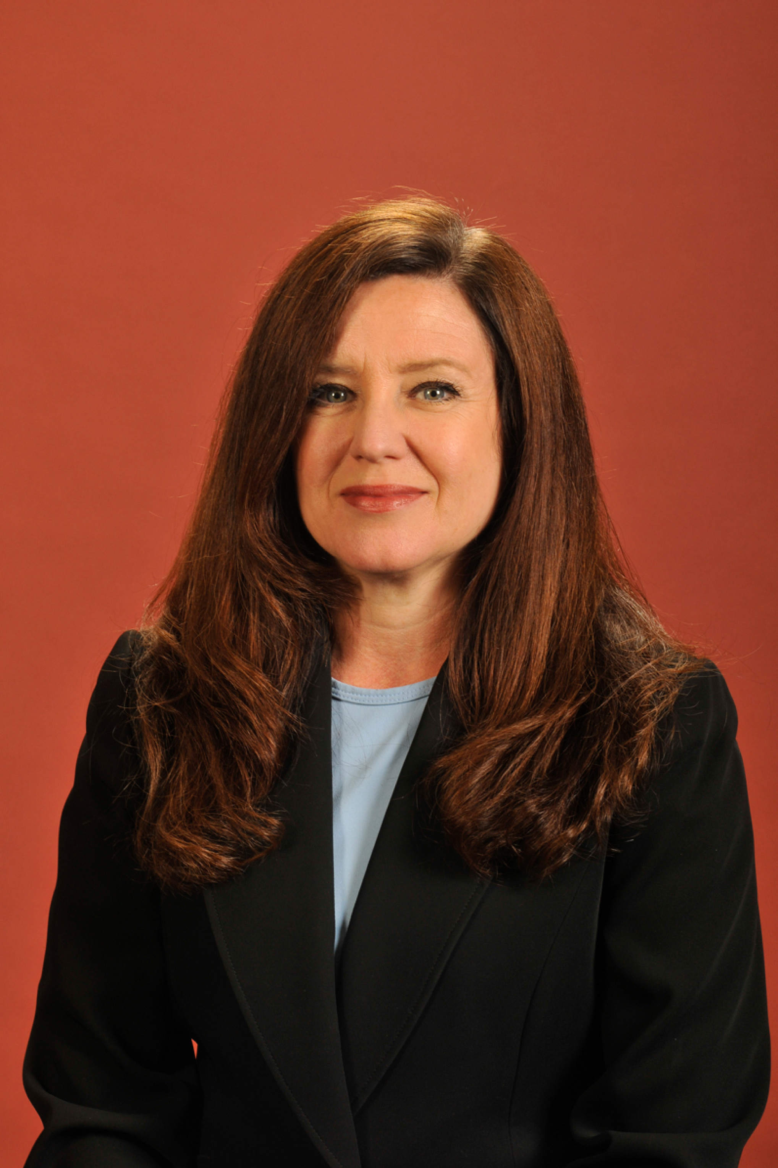
study group, and will soon begin meeting to prepare for PHR/SPHR winter testing dates (December 1, 2012 –January 31, 2013). The group will meet from 6:00 to 9:00 p.m. every Tuesday, beginning September 11, 2012, and ending Tuesday, December 11, 2012.

We’ll keep you posted regarding study group opportunities for the Spring 2013 testing window. Visit www.shrmsalem.org for future updates.
When you become certified, you're better able to show that you know the most current principles and core practices of HR management, you become more marketable when you compete for top HR positions, and you raise your professional confidence among your staff and peers. To learn more about certification, visit WWW.HRCI.org

Legal Update
David Briggs, SHRMA and Oregon State Council Legislative Director

Health Care Reform

You may be interested in reviewing this recent SHRM article regarding the U.S. Supreme Court‘s much-anticipated decision on the Obama administration’s health care reform law. Be sure to refer to the SHRM Online Health Care Reform Resource Page for information regarding how the decision will impact HR professionals. The law firm I work for has a health care attorney on staff who created a helpful Health Care Reform Compliance Guide for Employers I thought I’d share with you as well.

New Risks for Members and Managers of LLCs
The Oregon Court of Appeals recently issued a decision that members and managers of LLCs need to be aware of if they have employees. Most employers are aware that if an employee is injured on a job, the employee’s exclusive remedy for that injury is to file a workers’ compensation claim. In other words, employees generally can’t sue employers for on-the-job injuries. However, this new court of appeals decision allows employees to obtain their usual benefits under the workers’ compensation system and the sue members and managers of an LLC for their negligence (such as failure to properly train or supervise employees or follow proper safety procedures). That means that managers and members of LLC can be held individually liable for on-the-job injuries. Oregon employer groups plan to lobby the legislature to fix that provision to prevent employees from suing managers and members of LLCs. However, until a legislative fix is enacted, managers and members should consider taking steps to reduce their risk of liability. We will keep you posted throughout the next legislative session on the progress of any proposed legislation in this area. If you would like more information on this new case, feel free to contact me at (503) 399-1070 or dbriggs@sglaw.com.

Membership Update
Scott Cantu, SHRMA Membership Director and Oregon State Council Treasurer

If you’re a SHRM member and you regularly attend our Chapter meetings, please take the time to affiliate with our Chapter if you haven’t already done so. Part of our financing for the Salem Chapter is provided by SHRM in the form of reimbursement for SHRM members that become affiliated with our Chapter. This is an important and vital financial support that allows us in part to cover our expenses for monthly meetings. There’s no additional charge for affiliating with the Salem Chapter and it’s easily done by providing your SHRM ID and a statement requesting to affiliate with the Salem Chapter. Should you have questions or decide to affiliate with the Salem Chapter, please email Scott Cantu at scott.l.cantu@state.or.us
Chapter Programs Update
Deborah Jeffries, SHRMA and Oregon State Council Programs Director

Please click HERE or on the Chapter Meetings tab on our web site for a schedule of upcoming Chapter Programs. You may register for current programs there, as well by following the link provided. Please note that we will not be conducting an August Chapter breakfast meeting.
NHRMA Conference and Tradeshow – October 1 – 3, 2012 in Anchorage, Alaska

We wanted to take this opportunity to remind you about the upcoming NHRMA conference in Anchorage, Alaska. The theme is HR Leaders Driving Change, emphasizing the critical role HR plays in stabilizing and championing organizational change. There’s still time to register, but hurry and register by August 24 and avoid increased registration fees. Click HERE for conference information and to register on line.

Write the word “FUN” on your Calendar for October 24!

We’re planning our third annual SHRM Foundation fund-raising and networking event, and we ask that you set aside the evening of October 24 while we work out the details. We’re still in the planning stages, but we’ve set our sights on some wine tasting and a silent auction to benefit the SHRM Foundation.

Why do we support the SHRM Foundation? The SHRM Foundation is a 501(c)(3) nonprofit affiliate of SHRM. The Foundation is a legally separate organization, and is not funded by SHRM membership dues. Their work includes:

Innovative academic research grants. The SHRM Foundation is a leading funder of HR research. Over the past three years, the SHRM Foundation has awarded more than $1.8 million in grants to fund rigorous, original academic research with practical implications for HR management practice.
Scholarships. The SHRM Foundation awards $170,000 annually in education and certification scholarships to professional and student SHRM members, and doctoral students.
Educational resources. The SHRM Foundation's Effective Practice Guidelines series makes research findings easily accessible to HR practitioners. The Foundation has also created a series of educational DVDs for SHRM chapter programming, staff trainings, and executive education sessions.
Our support of the SHRM Foundation helps ensure they are able to continue the great work they do supporting HR professionals!
College Relations
Shelby Gould, College Relations Director/Treasurer

Willamette University's MBA Career Management Office is consistently seeking HR professionals for mock interviews, resume reviews, and information on interview tips and strategies at our career events. In addition, if your organization is hiring we have an internal job board to post internships and jobs for our MBA students and alumni.
To learn more about our career events and job board, please visit: http://www.willamette.edu/mba/career_management/employers/index.html
Contact Shelby Gould, Career Management Advisor, for more information: sgould@willamette.edu or 503.370.6167

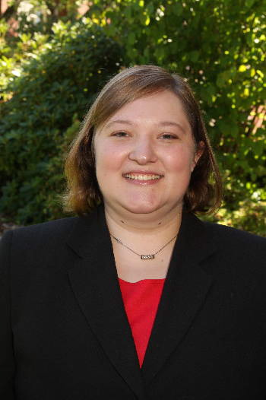 | Student Chapter  Tania Weets, Willamette University Student Chapter President  Willamette's SHRM student chapter is excited to start a new school year August 20th. We’ve already started planning events for the fall and we’re excited to welcome the new students. With support from the SHRM Oregon State Council and SHRMA, some student
Chapter members will be attending the NHRMA Conference in Alaska this year! We’re excited for this opportunity to learn more about Human Resources and share what we learn with those who could not attend the conference.
Stay connected to the Willamette University SHRM chapter to see the latest events at: http://willamette.edu/org/shrm/
If you are available to be a mentor, host a job shadow, or help out with Willamette's student chapter, please email me at tweets@willamette.ed, or contact Shelby Gould at sgould@willamette.edu
Easter Seals Update

If you’ve attended our breakfast meetings in the past, you’ve had the opportunity to hear from Janet Norton, Program Manager of Easter Seals Oregon Employment Services. She has brought several Easter Seals Veterans Reintegration Program job ready candidates to these meetings. Janet is pleased to announce that several of those candidates are now employed as a result of the training they’ve received through the Easter Seals Oregon program.

Easter Seals staff is currently busy planning employment events for September 24 and 28. The September 24 event is an employment conference for all of their program recipients and will include seniors and Veterans. Janet is looking for workshop presenters. The September 28 event is a Veteran Stand Down that is community wide and a valued annual event. Janet is seeking volunteers to participate for 2 hours in giving employment tips. This is a great way for us to support Easter Seals Oregon, our adopted program. If you are interested in these opportunities, please contact Janet directly at jnorton@or.easterseals.com. Thank you for your support!
Are you or is someone you know interested in sponsoring a Chapter meeting? Top of Form
SHRMA Sponsorship Opportunities
Are you, or is someone you know, interested in sponsoring a Chapter meeting? Meeting sponsors ensure that we continue to offer the quality of programs we as a Chapter are committed to providing our members. We offer four levels of sponsorship opportunities to meet the advertising needs of businesses. More information regarding sponsorship opportunities is available by clicking on the Sponsorship tab on our web site located at shrmsalem.org.

Employment Opportunities
If you know of an employment opportunity in the area of Human Resources and would like us to post it on our web site, please feel free to contact Barbara Cecil (bcecil@mapscu.com) or Shauneen Scott (Shauneen.K.Scott@doc.state.or.us). Positions will be posted for one month unless other arrangements are made.

